Jordan Gales
Slide 1

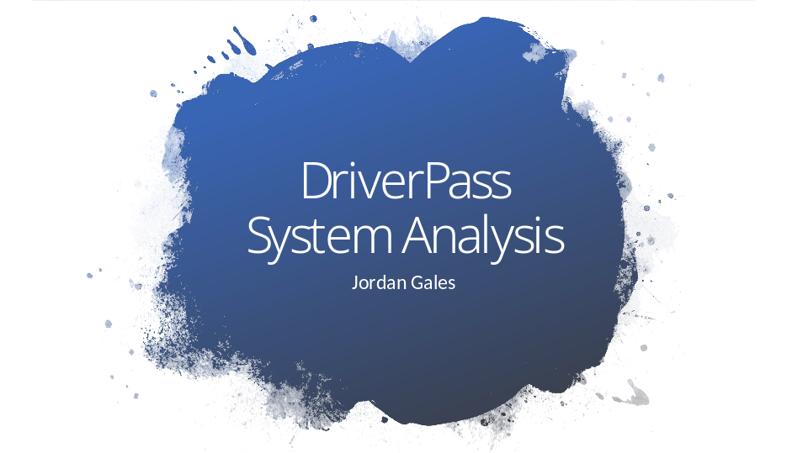

[No speaker notes required for this slide.]

Slide 2

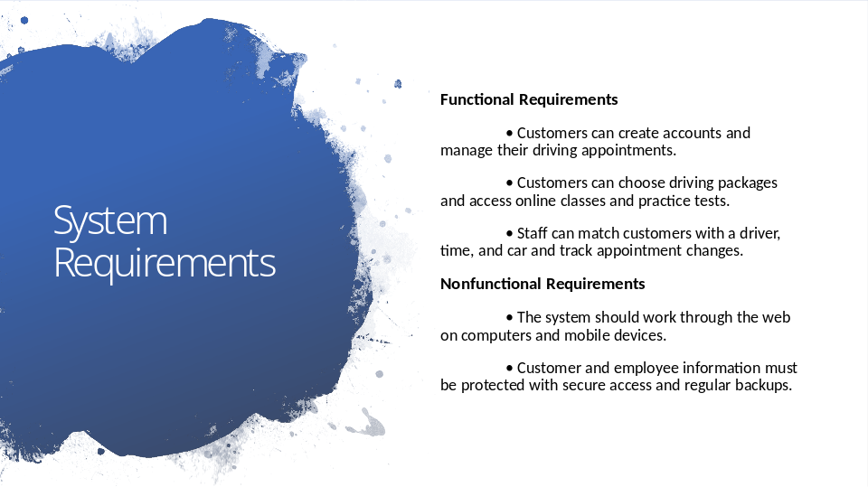

On this slide, I am separating what the DriverPass system needs to do from the qualities the system needs to have. The main functions are helping customers create accounts, manage appointments, choose a driving package, and use the online classes and practice tests. The staff side also needs to match students with the right driver, time, and car and keep track of appointment changes. For the system itself, DriverPass wants web access from different devices, along with protection for customer and employee information. These requirements support the goal of making the business easier to manage while giving customers a simple way to schedule and complete their training.

Slide 3

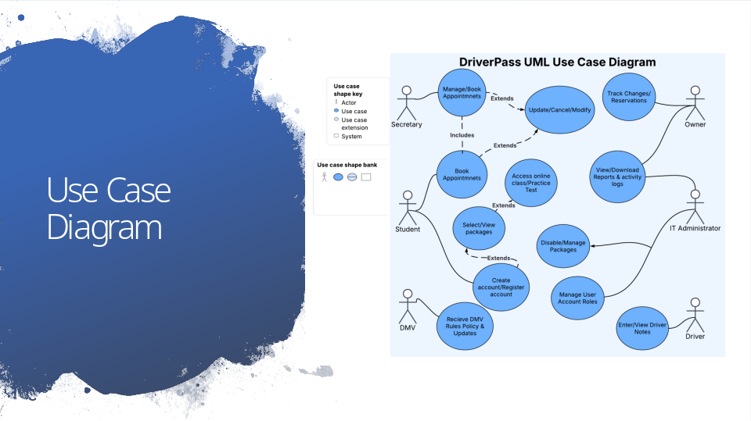

This diagram gives us a high-level picture of who will use the DriverPass system and what they need to do. Customers can create an account, sign in, choose packages, book and change appointments, access online classes and practice tests, and view their progress. The secretary can help customers with registration and appointments. Drivers can add lesson notes, while the owner can review reports and activity. The IT administrator manages employee access and packages. The DMV is shown outside the system because DriverPass needs to receive updated rules, policies, and test information from the DMV. Overall, the design focuses on the daily tasks identified in the interview.

Slide 4

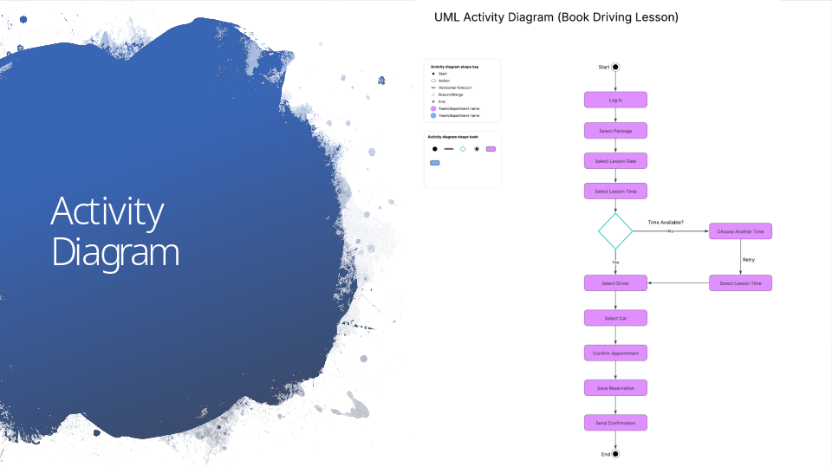

This example breaks down the process of booking a driving lesson. A customer first signs in and selects a package, then chooses a date and time. The system checks whether that time is available. If it is not available, the customer can choose another time instead of losing the appointment process. Once a time is available, the customer selects a driver and a car, confirms the appointment, and the reservation is saved. A confirmation is then sent to the customer. This design supports DriverPass's requirement that each lesson be scheduled for a specific day and time and matched with the correct driver and car.

Slide 5

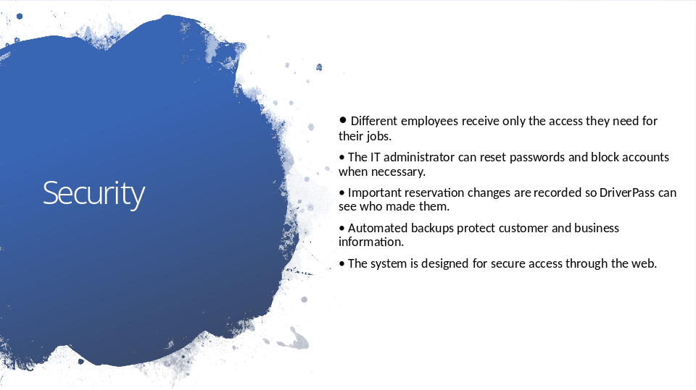

Security is important because DriverPass will store customer information, appointment information, and employee accounts. The design separates employee responsibilities so people only have the access needed for their jobs. The IT administrator can reset passwords and block access when an employee should no longer use the system. The system also keeps a record of important reservation changes, which helps the owner understand who made a change if there is a problem. Regular backups provide another layer of protection for the business information. These choices are intended to keep the system safe without making it difficult for employees to use.

Slide 6

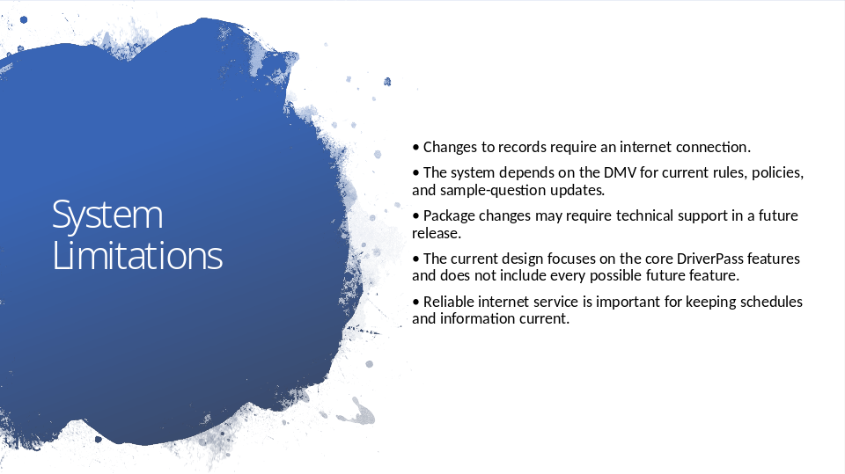

There are a few limits to the current design. First, the interview explains that information can be viewed offline, but changes should only be made while connected to the internet. The system also depends on the DMV to provide current rules, policies, and sample questions, so DriverPass cannot control when the DMV sends an update. Another limitation is that changing or adding packages may require technical assistance in a future release. Finally, this design focuses on the main features discussed during the interview, so additional features could be added later as DriverPass grows. These limitations do not prevent the system from meeting the main business needs, but they are important to keep in mind.

